**USA Crime Analysis**

1. Write a MapReduce/pig program to calculate the number of cases investigated under each FBI code

Sol:

* Register piggybank.jar File.
* Download csvfile(dataset) and load csv using CsvExcelStorage command and perform the operations.

Commands:

* REGISTER '/home/acadgild/pig-0.16.0/lib/piggybank.jar';
* A = LOAD '/home/acadgild/CrimesTpresent.csv' using org.apache.pig.piggybank.storage.CSVExcelStorage(',' , 'NO_MULTILINE','UNIX','SKIP_INPUT_HEADER') as (ID: chararray, Case_Num: chararray, date: chararray, block: chararray, IUCR: chararray, type: chararray, desc: chararray, arrest:chararray, domestic :chararray, beat:chararray, district:chararray, ward:chararray, area:chararray, FBI_Code:chararray, X:chararray, Y:chararray, year: int , updated_on : chararray, lat: chararray, long: chararray, location:chararray);
* B = GROUP A BY FBI_Code;
* C = FOREACH B GENERATE FLATTEN(group) AS FBI_Code, COUNT(A.FBI_Code) ;
* DUMP C;

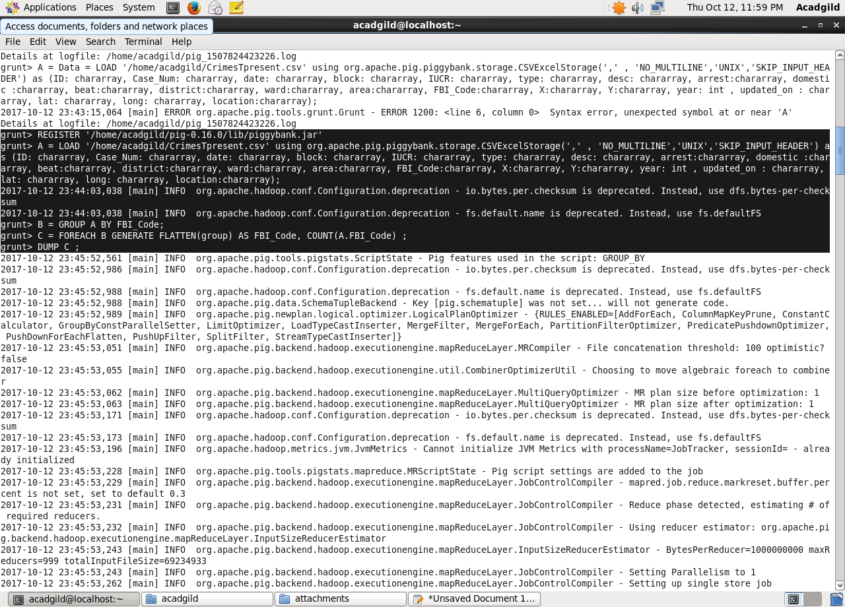

Output:

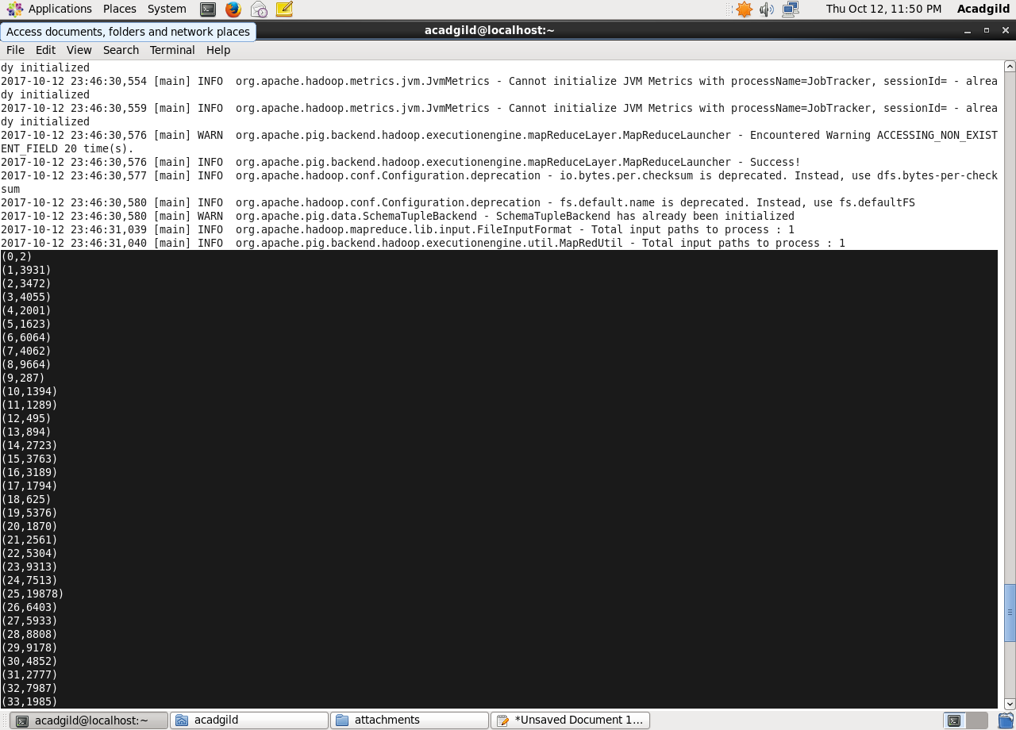

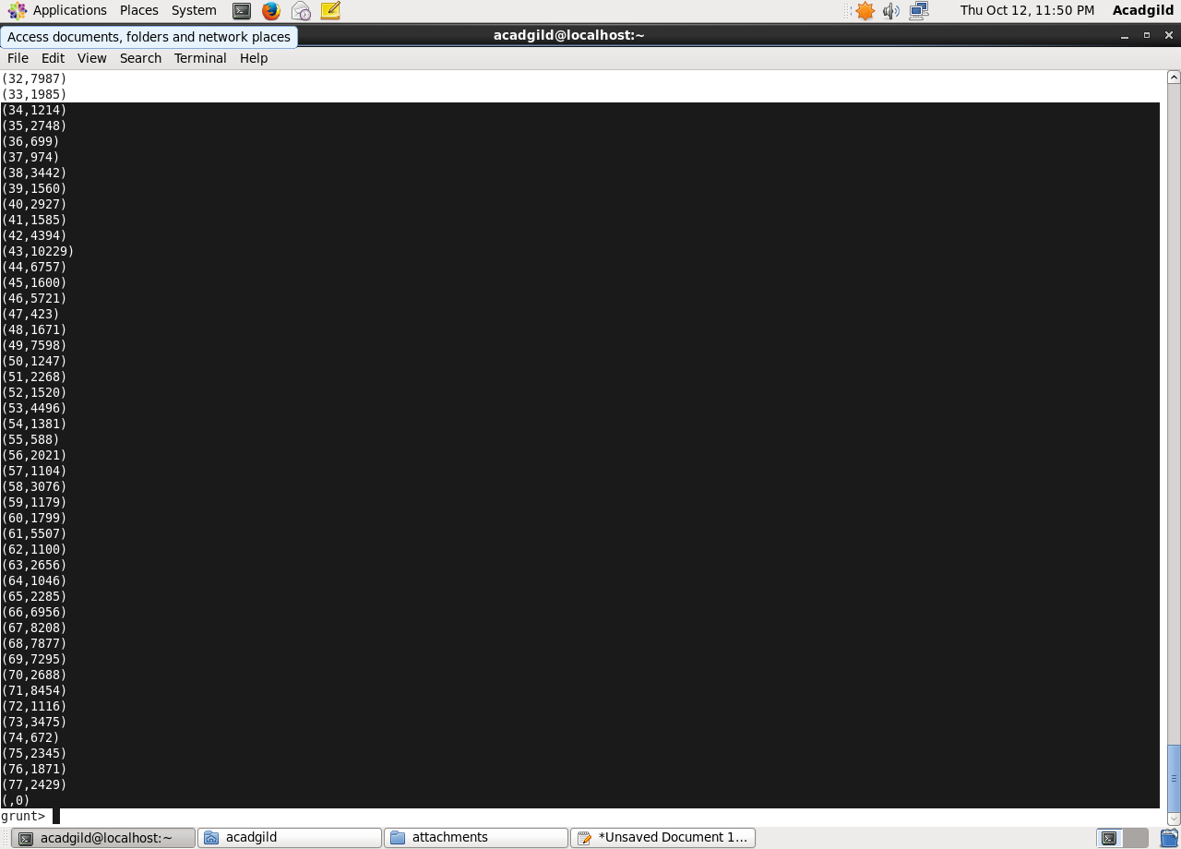

1. Write a mapreduce/Pig program to calculate the number of cases investigated under FBI code 32.

Sol:

* REGISTER ‘/home/acadgild/pig-0.16.0/lib/piggybank.jar';
* A = LOAD '/home/acadgild/CrimesTpresent.csv' using org.apache.pig.piggybank.storage.CSVExcelStorage(',' , 'NO_MULTILINE','UNIX','SKIP_INPUT_HEADER') as (ID: chararray, Case_Num: chararray, date: chararray, block: chararray, IUCR: chararray, type: chararray, desc: chararray, arrest:chararray, domestic :chararray, beat:chararray, district:chararray, ward:chararray, area:chararray, FBI_Code:chararray, X:chararray, Y:chararray, year: int , updated_on : chararray, lat: chararray, long: chararray, location:chararray);
* FBI_32 = FILTER A BY FBI_Code == '32';
* Group_32 = GROUP FilterData ALL;
* CAL = FOREACH Group_32 GENERATE FLATTEN(group) AS district, COUNT(FBI_32.ID) ;
* DUMP CAL;

Commands:

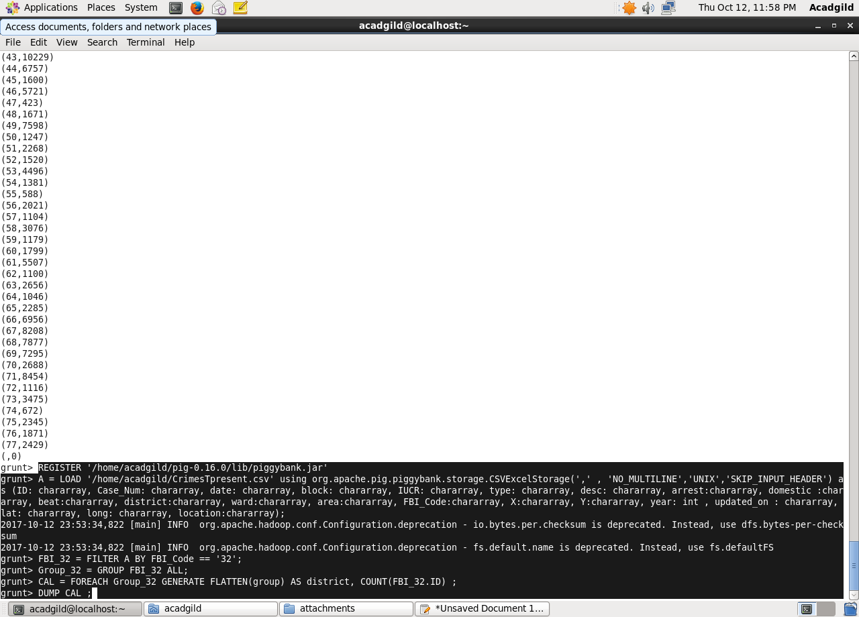

Output:

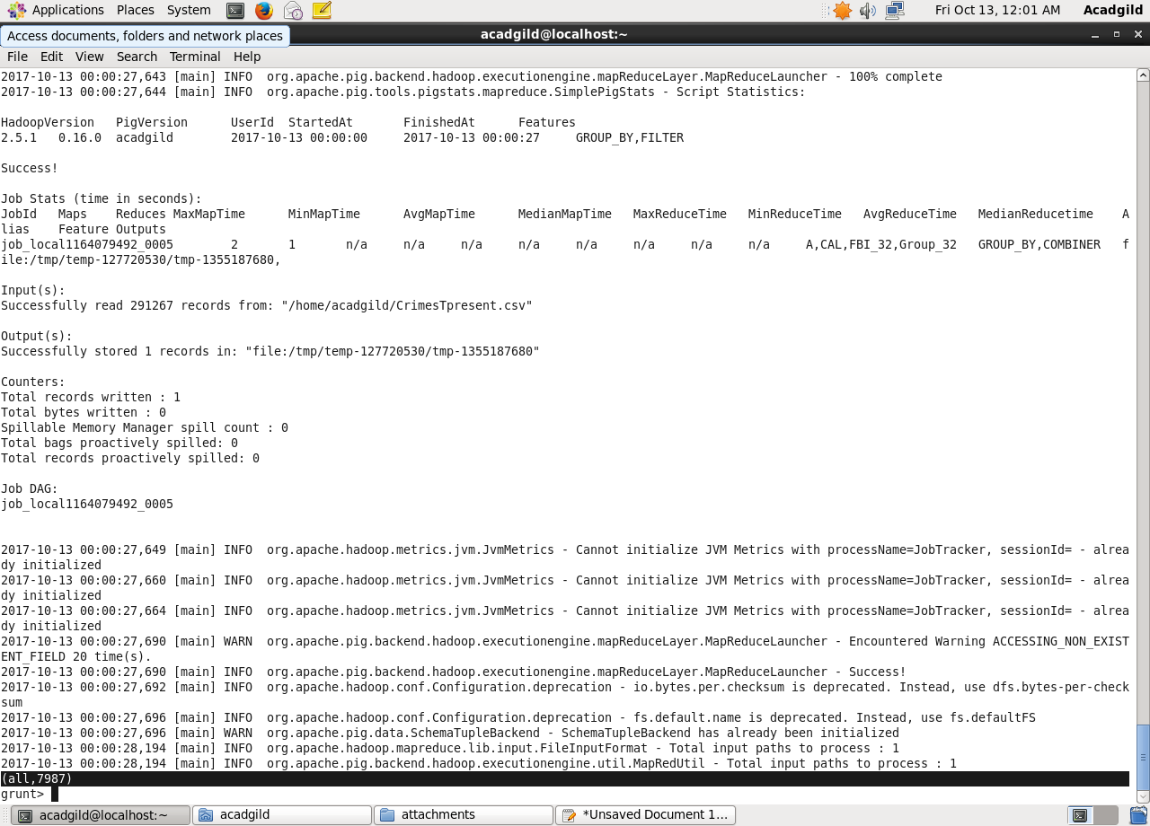

3.Write a Mapreduce/pig program to calculate the number of arrests in theft district wise.

Sol:

* REGISTER ‘/home/acadgild/pig-0.16.0/lib/piggybank.jar';
* A = LOAD '/home/acadgild/CrimesTpresent.csv' using org.apache.pig.piggybank.storage.CSVExcelStorage(',' , 'NO_MULTILINE','UNIX','SKIP_INPUT_HEADER') as (ID: chararray, Case_Num: chararray, date: chararray, block: chararray, IUCR: chararray, type: chararray, desc: chararray, arrest:chararray, domestic :chararray, beat:chararray, district:chararray, ward:chararray, area:chararray, FBI_Code:chararray, X:chararray, Y:chararray, year: int , updated_on : chararray, lat: chararray, long: chararray, location:chararray);
* Filter_Theft = FILTER A BY type =='THEFT';
* Group_dis = GROUP Filter_Theft BY district;
* ARR = FOREACH Group_dis GENERATE FLATTEN(group) AS district, COUNT(Filter_Theft.district) ;
* DUMP ARR;

Commands:

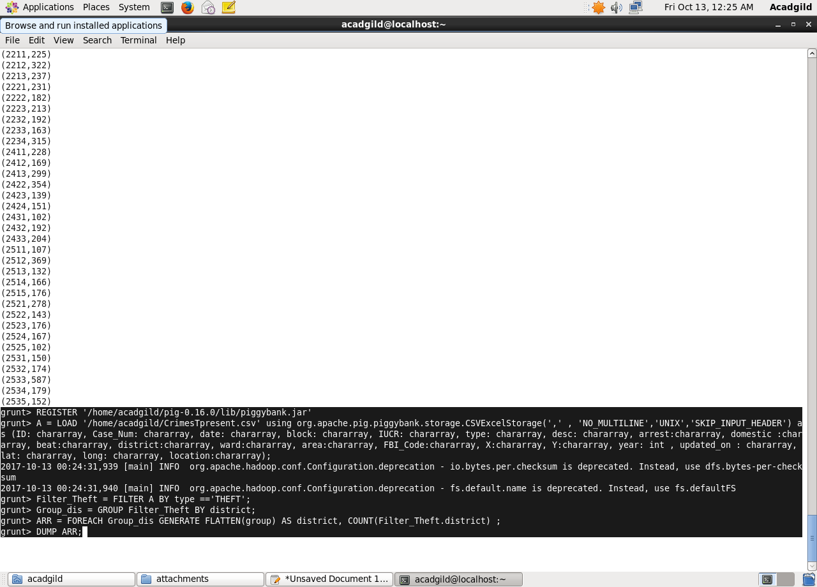

Output:

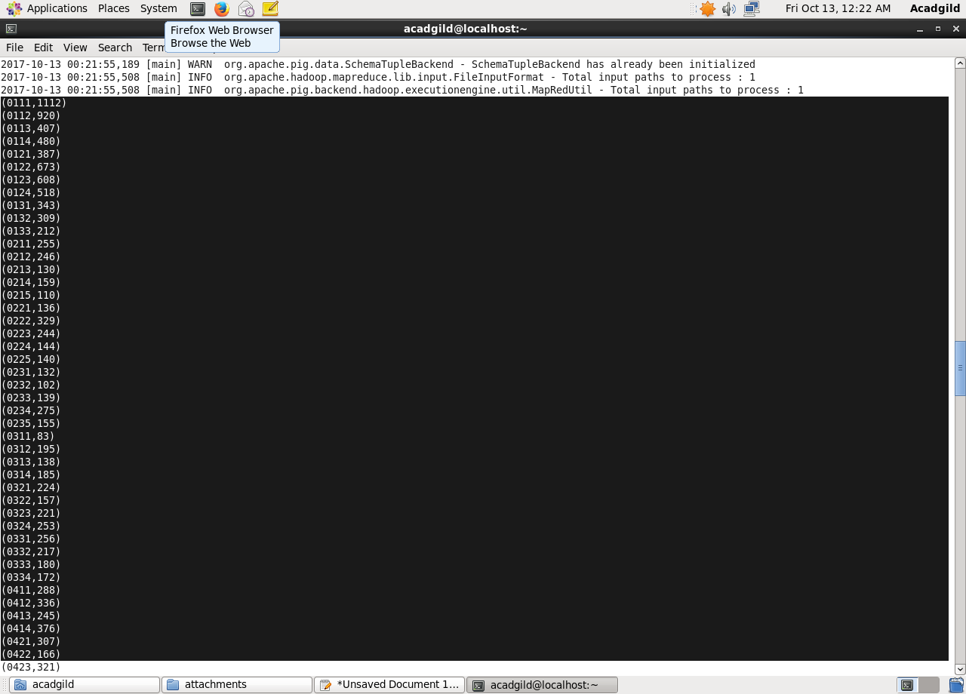

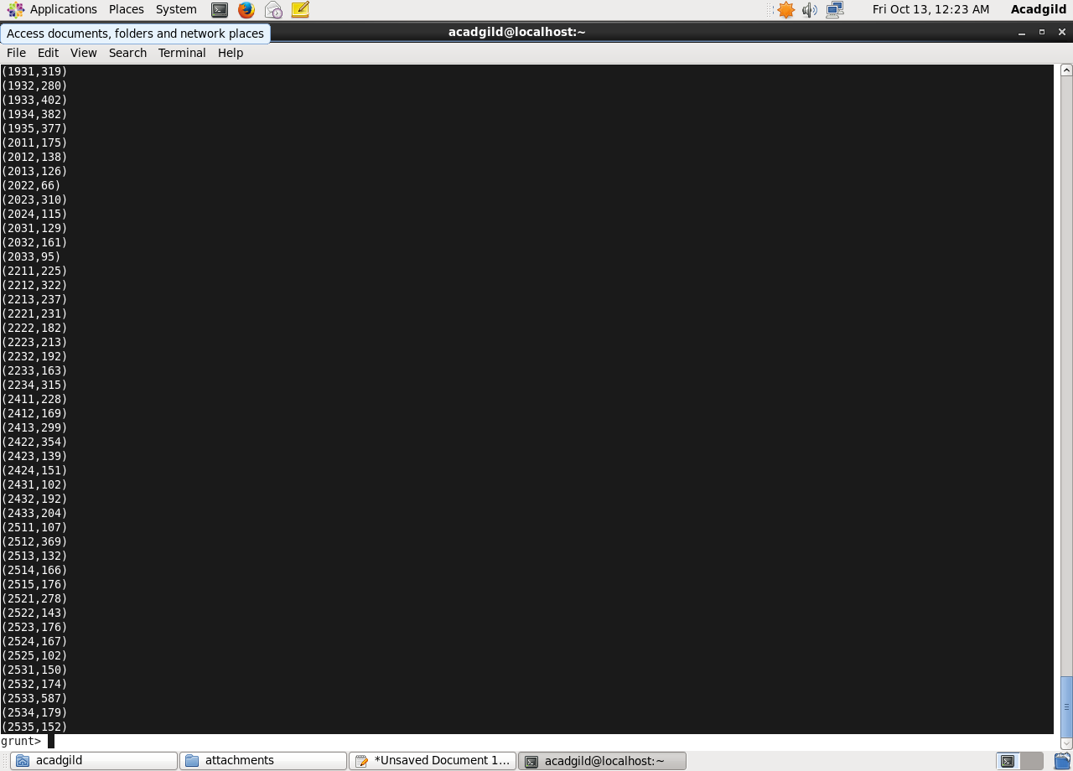

4.Write a MapReduce/PIG script to calculate the number of arrests done between october 2014 and october 2015

Sol:

* REGISTER ‘/home/acadgild/pig-0.16.0/lib/piggybank.jar';
* A = LOAD '/home/acadgild/CrimesTpresent.csv' using org.apache.pig.piggybank.storage.CSVExcelStorage(',' , 'NO_MULTILINE','UNIX','SKIP_INPUT_HEADER') as (ID: chararray, Case_Num: chararray, date: chararray, block: chararray, IUCR: chararray, type: chararray, desc: chararray, arrest:chararray, domestic :chararray, beat:chararray, district:chararray, ward:chararray, area:chararray, FBI_Code:chararray, X:chararray, Y:chararray, year: int , updated_on : chararray, lat: chararray, long: chararray, location:chararray);
* OCT = FOREACH A GENERATE ToDate(SUBSTRING(date,0,10), 'MM/dd/yyyy') as (dt:datetime);

grunt>FilterOCT14 = FILTER OCT BY DaysBetween(dt,(datetime)ToDate('10/01/2014', 'MM/dd/yyyy')) >=(long)0;

* FilterOCT15 = FILTER FilterOCT14 BY DaysBetween(dt,(datetime)ToDate('10/01/2015', 'MM/dd/yyyy')) <=(long)0;
* GroupArr = GROUP FilterOCT15 ALL;
* TOT = FOREACH GroupArr GENERATE COUNT(FilterOCT15) ;
* DUMP TOT;

Commnads:

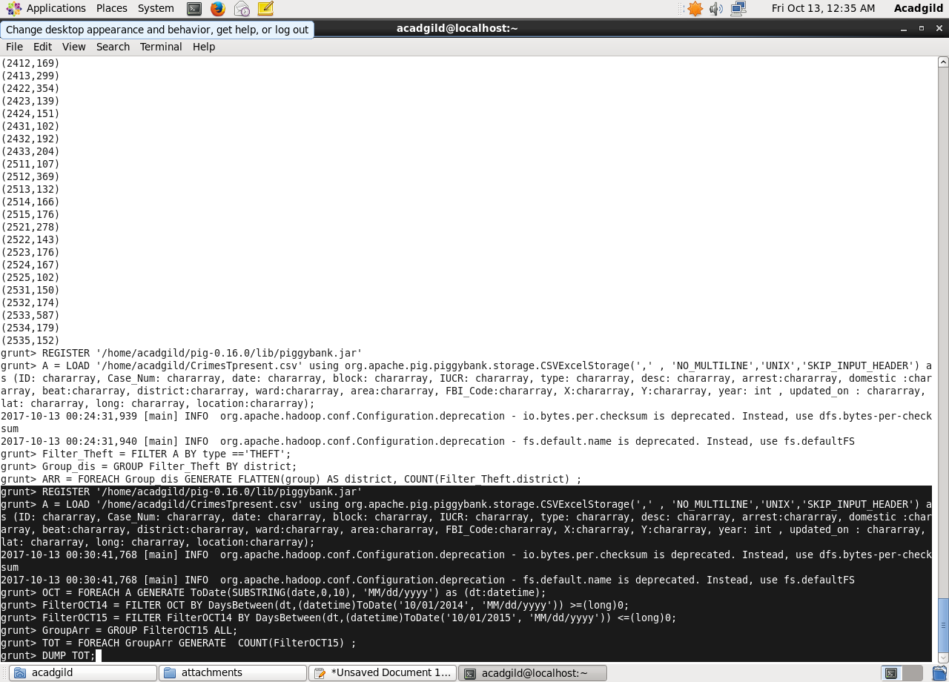

Output:

